**Vehicle Tracking Report**

I have used this dataset: <https://github.com/udacity/self-driving-car/tree/master/annotations>

I have trained this model using YOLOV3 object detection technique. Because, it is a faster and gives more accurate result then others techniques. Also, I don’t have GPU facility so for me YOLOV3 is more suitable.

Here is the accuracy of this object detection model on testing data. F1_score if 0.83 and mAp is 0.86.

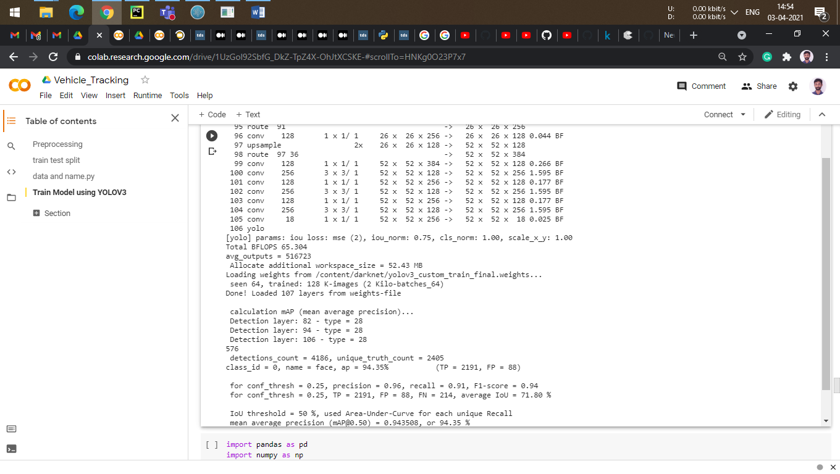

**Tracking**:

For the tracking I have used cosine function and Nearest Neighbour Metric. I continuously monitoring the object continuously throughout the video. Once the object cross the threshold line then it will be counted.

Here is my GitHub link where I have uploaded this project:- <https://github.com/dhaval-zala/Vehicle_Tracking>

Output file:- https://drive.google.com/drive/folders/1ZJLanvcupYfYbYMnBEYRv_FveIqS5iKq?usp=sharing

Example:

